Your NAME

CPE301 – SPRING 2018

Design Assignment X

**DO NOT REMOVE THIS PAGE DURING SUBMISSION:**

The student understands that all required components should be submitted in complete for grading of this assignment.

|  |  |  |  |
| --- | --- | --- | --- |
| **NO** | **SUBMISSION ITEM** | **COMPLETED (Y/N)** | **MARKS**  **(/MAX)** |
| 1 | COMPONENTS LIST AND SCHEMATICS |  |  |
| 2. | TASK #1 ASSEMBLY CODE |  |  |
| 3. | TASK #1 C CODE |  |  |
| 4. | TASK #1 SIMULATION |  |  |
| 5. | TASK #2 ASSEMBLY CODE |  |  |
| 6. | TASK #2 C CODE |  |  |
| 7. | TASK #2 SIMULATION |  |  |
| 8. | TASK #3 ASSEMBLY CODE |  |  |
| 9. | TASK #3 C CODE |  |  |
| 10. | TASK #3 SIMULATION |  |  |
| 11. | TASK #4 ASSEMBLY CODE |  |  |
| 12. | TASK #4 C CODE |  |  |
| 13. | TASK #4 SIMULATION |  |  |
| 14. | TASK #5 ASSEMBLY CODE |  |  |
| 15. | TASK #5 C CODE |  |  |
| 16. | TASK #5 SIMULATION |  |  |
|  |  |  |  |
|  |  |  |  |

1. **COMPONENTS LIST AND SCHEMATICS**

Red LED

Switch

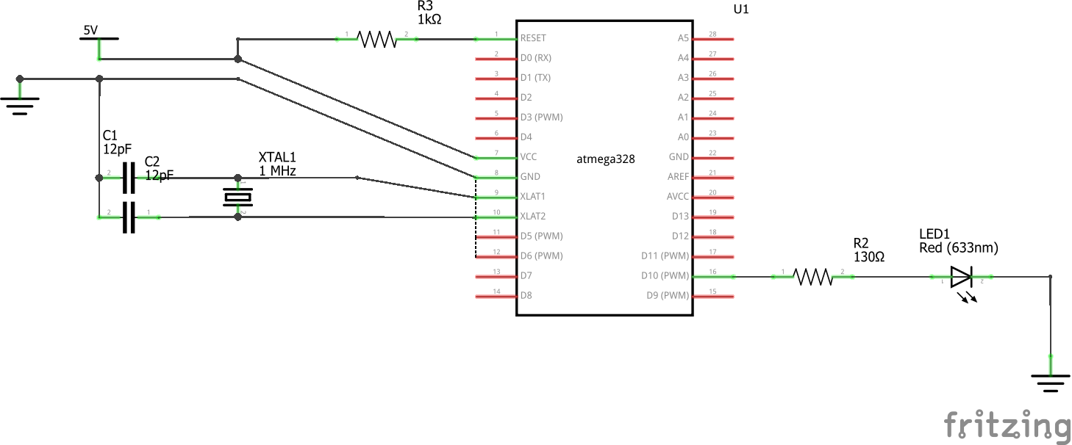

Schematic for Task #1, #3, and #4

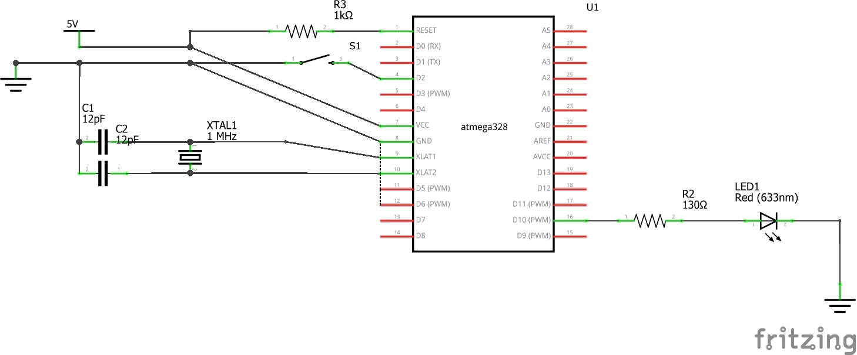

Schematic for Task #2 and #5

1. **Task #1 Assembly Code**

.ORG 0

; Initialize the stack

LDI R16, HIGH(RAMEND)

OUT SPH, R16

LDI R16, LOW(RAMEND)

OUT SPL, R16

SBI DDRB, 2 ; Set PORTB as output

LDI R16, (1<<2) ; Output signal of PORTB

LDI R17, 0x0

OUT PORTB, R17 ; Clear PORTB

; Toggle PB2 port

BEGIN:

RCALL DELAY

EOR R17, R16 ; Toggle logic

OUT PORTB, R17 ; Output the toggled signal

RJMP BEGIN

; Delay for 0.25 second

; Delay subroutine using Timer1 (F = 0.5 MHz)

DELAY:

; Set the TCNT1 = 65536-15625 = 49911

LDI R20, HIGH(-15625)

STS TCNT1H, R20

LDI R20, LOW(-15625)

STS TCNT1L, R20

; Start the timer with a prescalar of 8

LDI R20, 0x00

STS TCCR1A, R20

LDI R20, 0x02

STS TCCR1B, R20

; Delay for 31250 cycles

LOOP:

IN R20, TIFR1

SBRS R20, TOV1

RJMP LOOP

; Stop timer and reset TOV flag

LDI R20, 0x0

STS TCCR1B, R20

LDI R20, (1<<TOV1)

OUT TIFR1, R20

RET

1. **Task #1 C Code**

#include <avr/io.h>

void T1Delay();

int main(void)

{

DDRB |= 0x04; // Set PORTB.2 as output

PORTB = 0x00; // Clear PORTB

while(1)

{

T1Delay(); // Call delay

PORTB ^= 0x04; // Toggle the LED

}

return 0;

}

// Function that uses Timer1 [Delay for 0.25 second]

// F = 0.5 MHz

void T1Delay()

{

// Set the TCNT1 = 0xC2F7 [65536-15625 = 49911]

TCNT1H = 0xC2;

TCNT1L = 0xF7;

// Start clock using prescalar 8

TCCR1A = 0x00;

TCCR1B = 0x02;

while((TIFR1&0x01) == 0); // Loop until TOV flag is set

TCCR1B = 0x00; // Stop the timer

TIFR1 |= 0x01; // Reset TOV flag

}

1. **Task #1 Simulation**

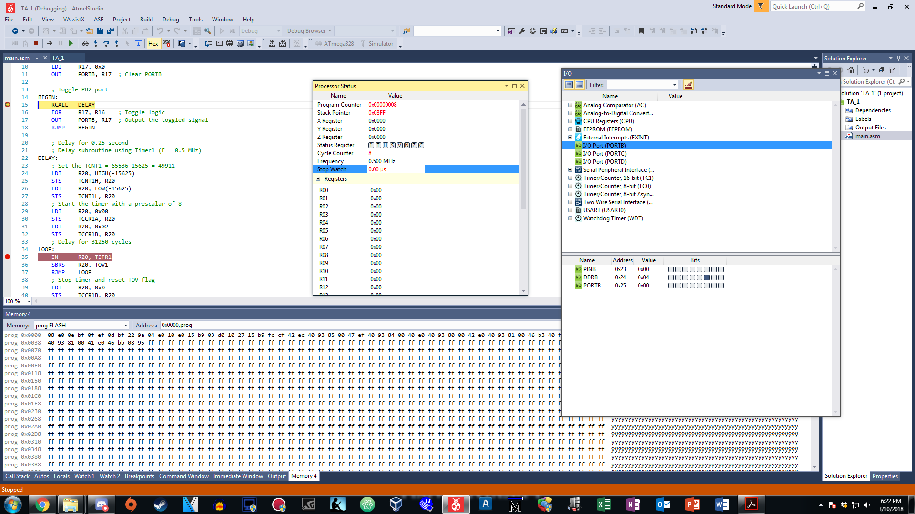

*Figure 1: Before the call of delay, PB.2 is cleared and stopwatch ready (ASM)*

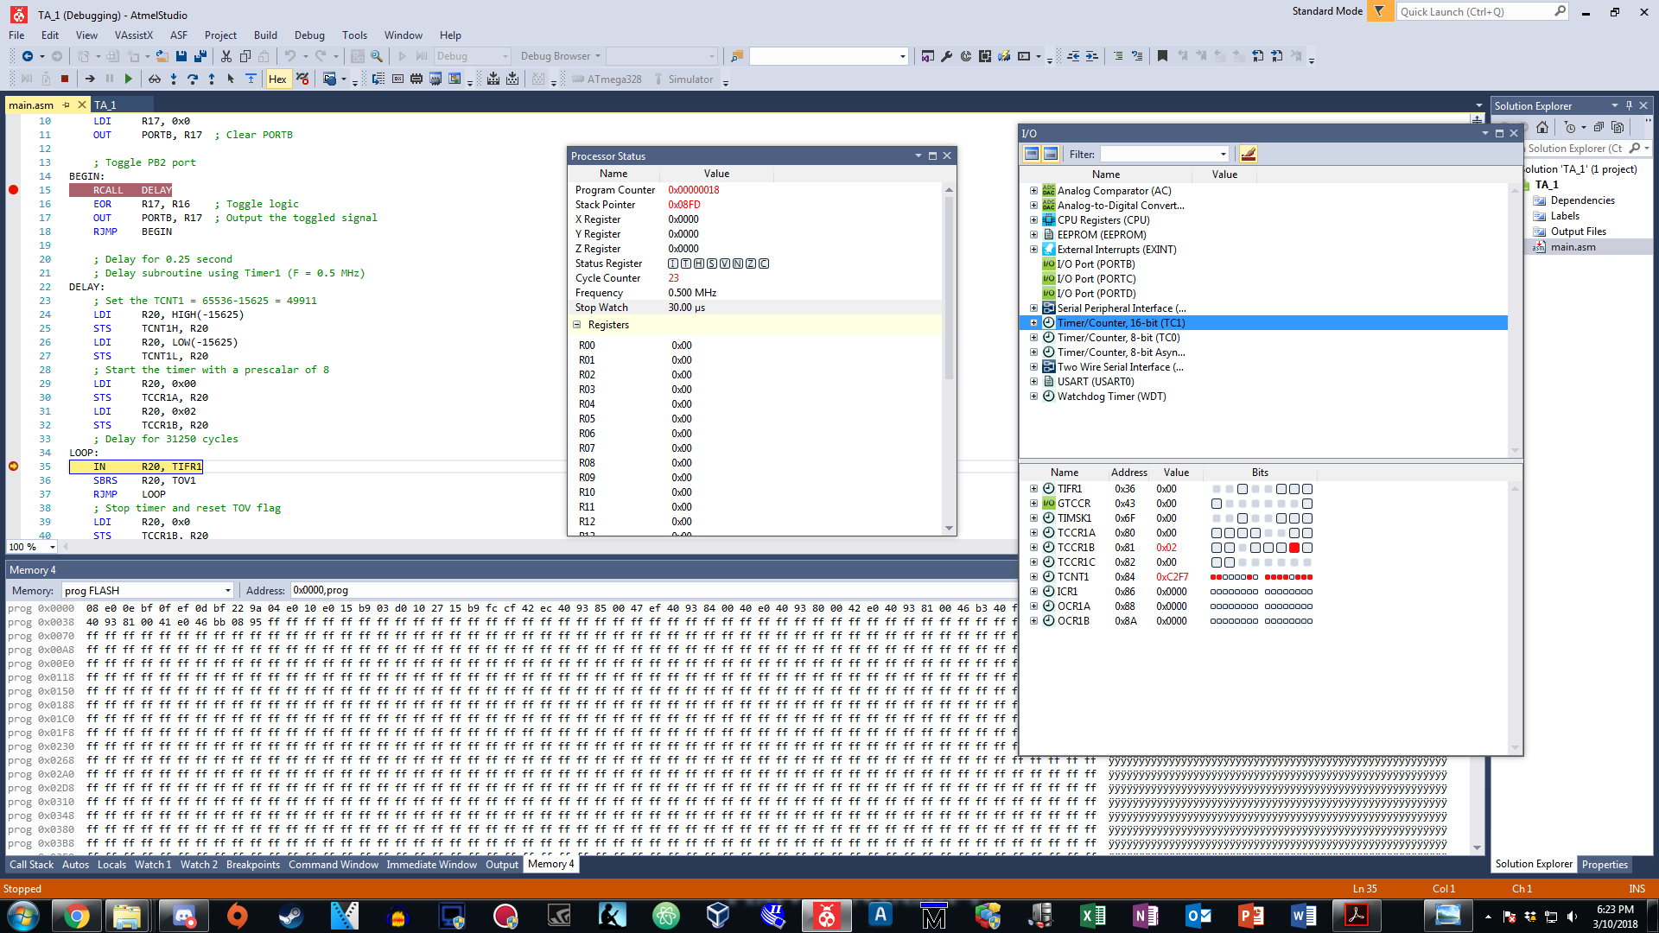

*Figure 2: TIMER1 registers are set to count in the delay subroutine (ASM)*

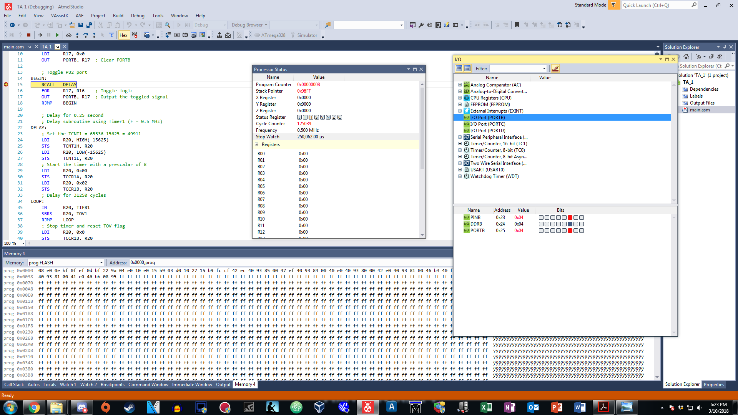

*Figure 3: After 0.25 second delay, PB.2 toggles high (ASM)*

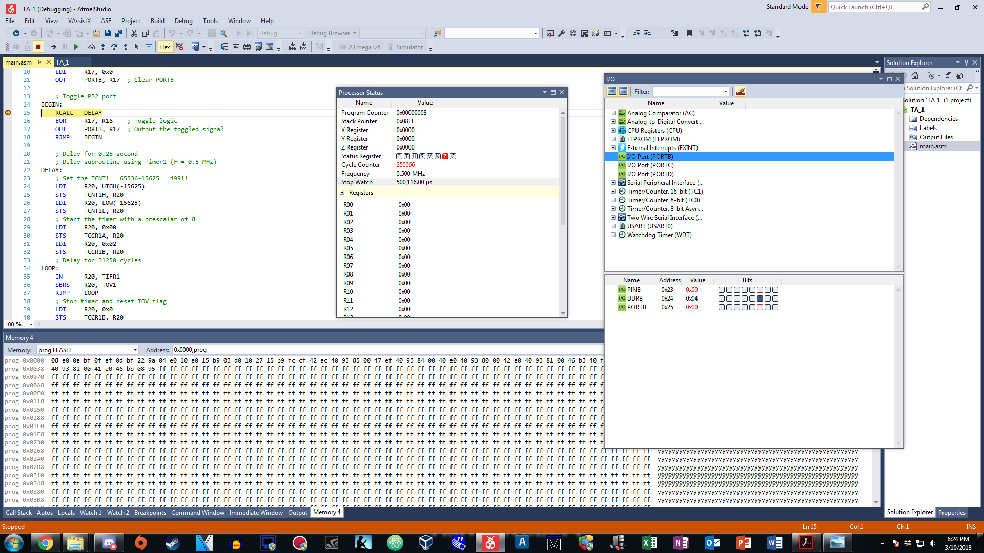

*Figure 4: Another 0.25 second of delay, PB.2 toggles to low again (ASM)*

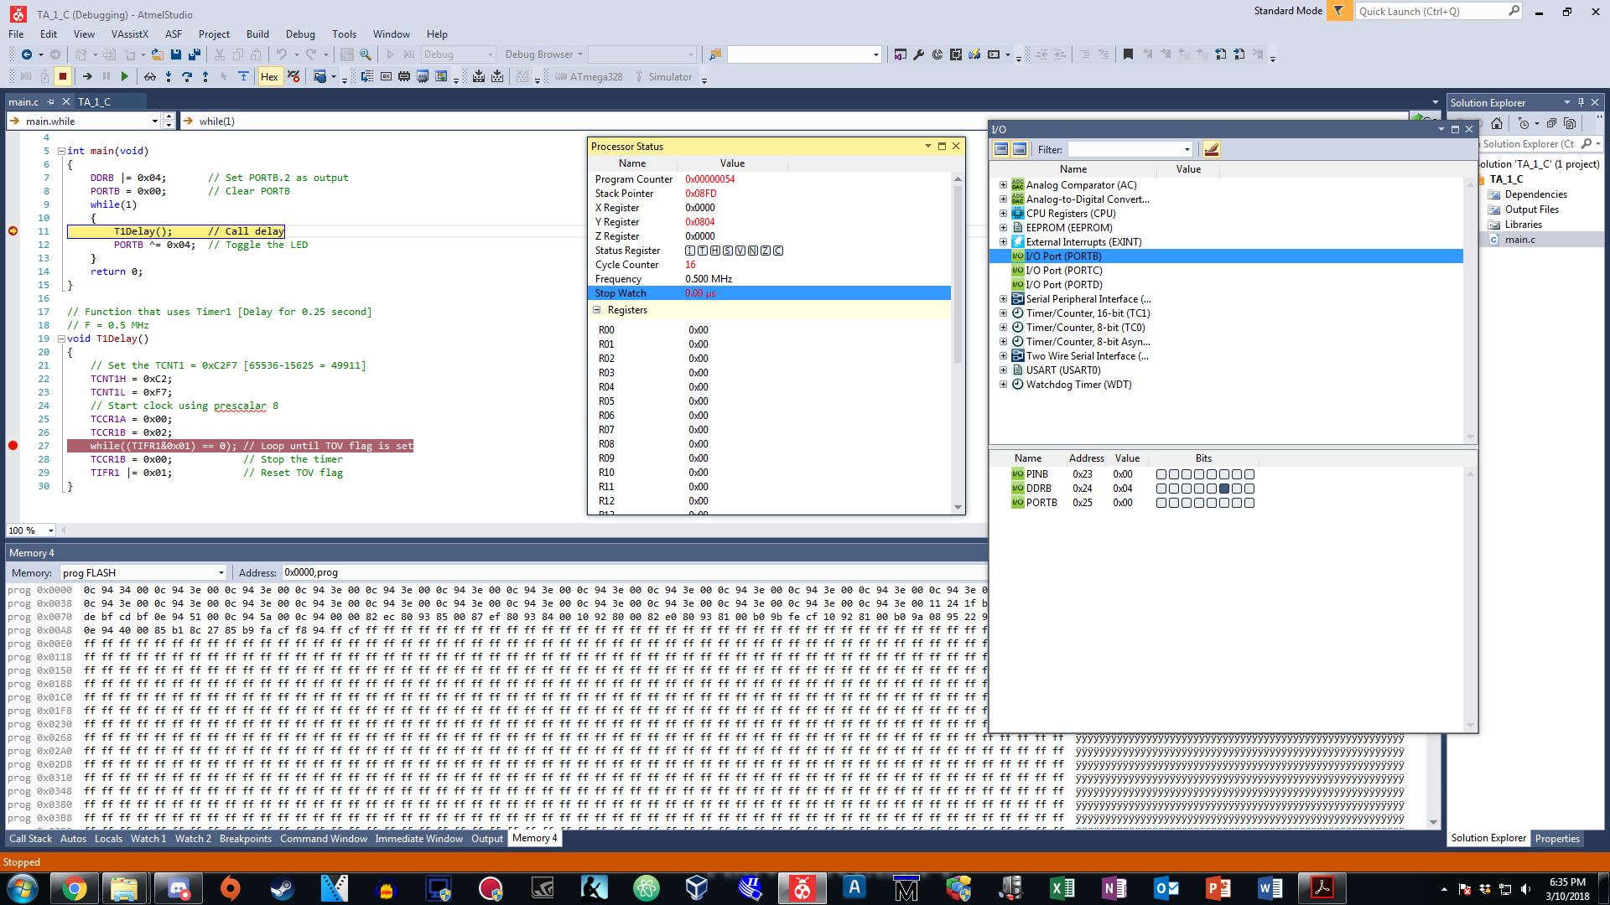

*Figure 5: Before the call of delay, PB.2 is cleared and stopwatch ready (C)*

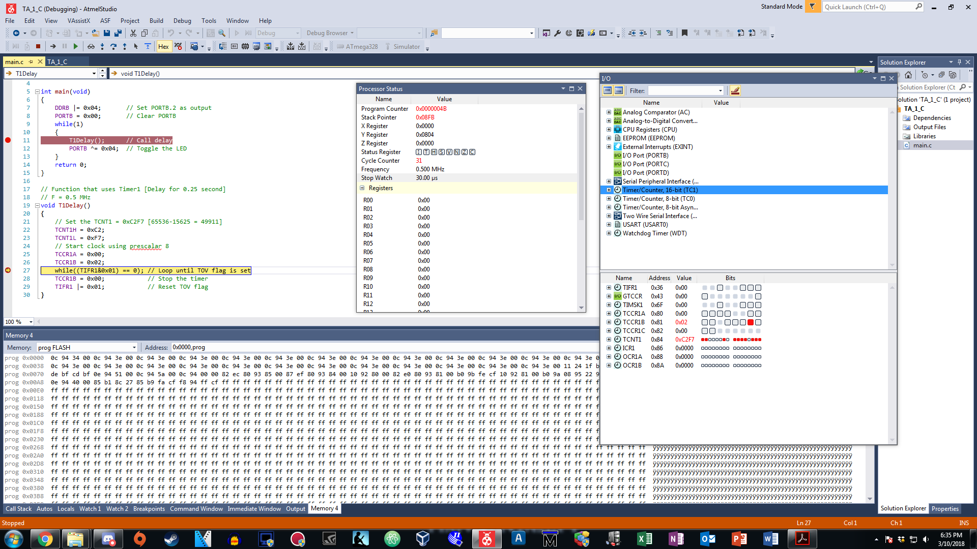

*Figure 6: TIMER1 registers are set to count in the delay subroutine (C)*

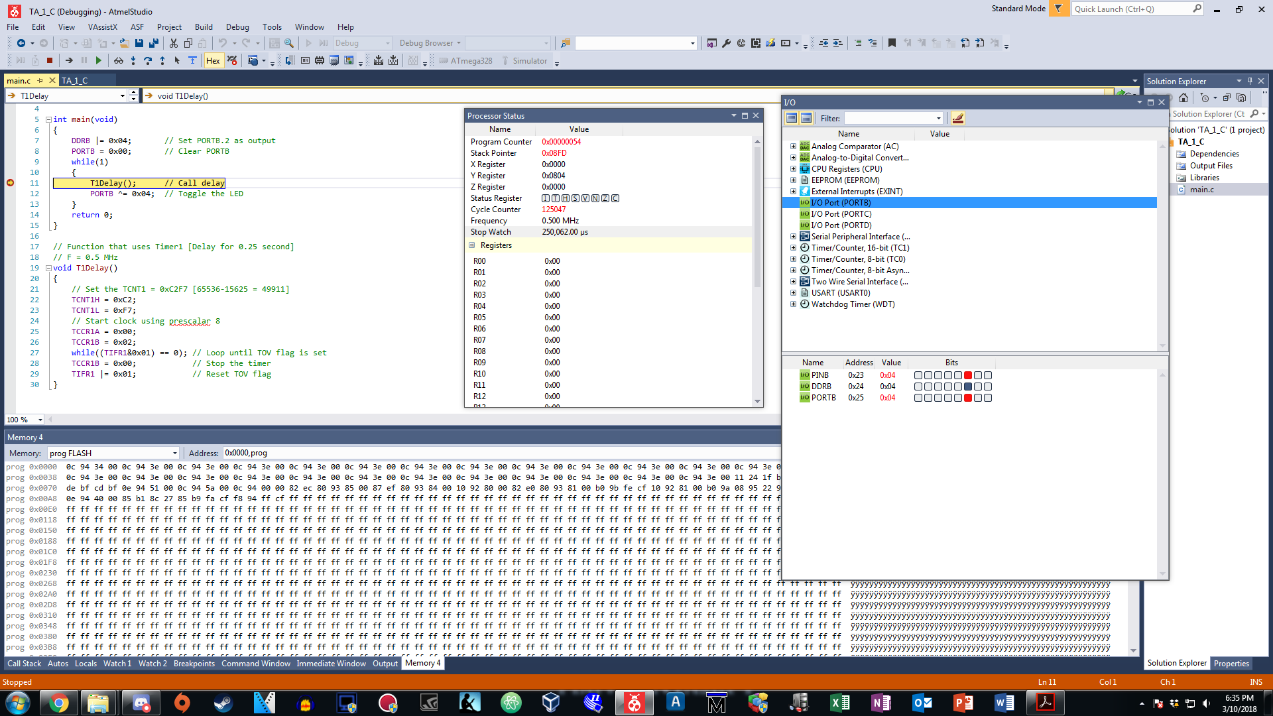

*Figure 7: After 0.25 second delay, PB.2 toggles high (C)*

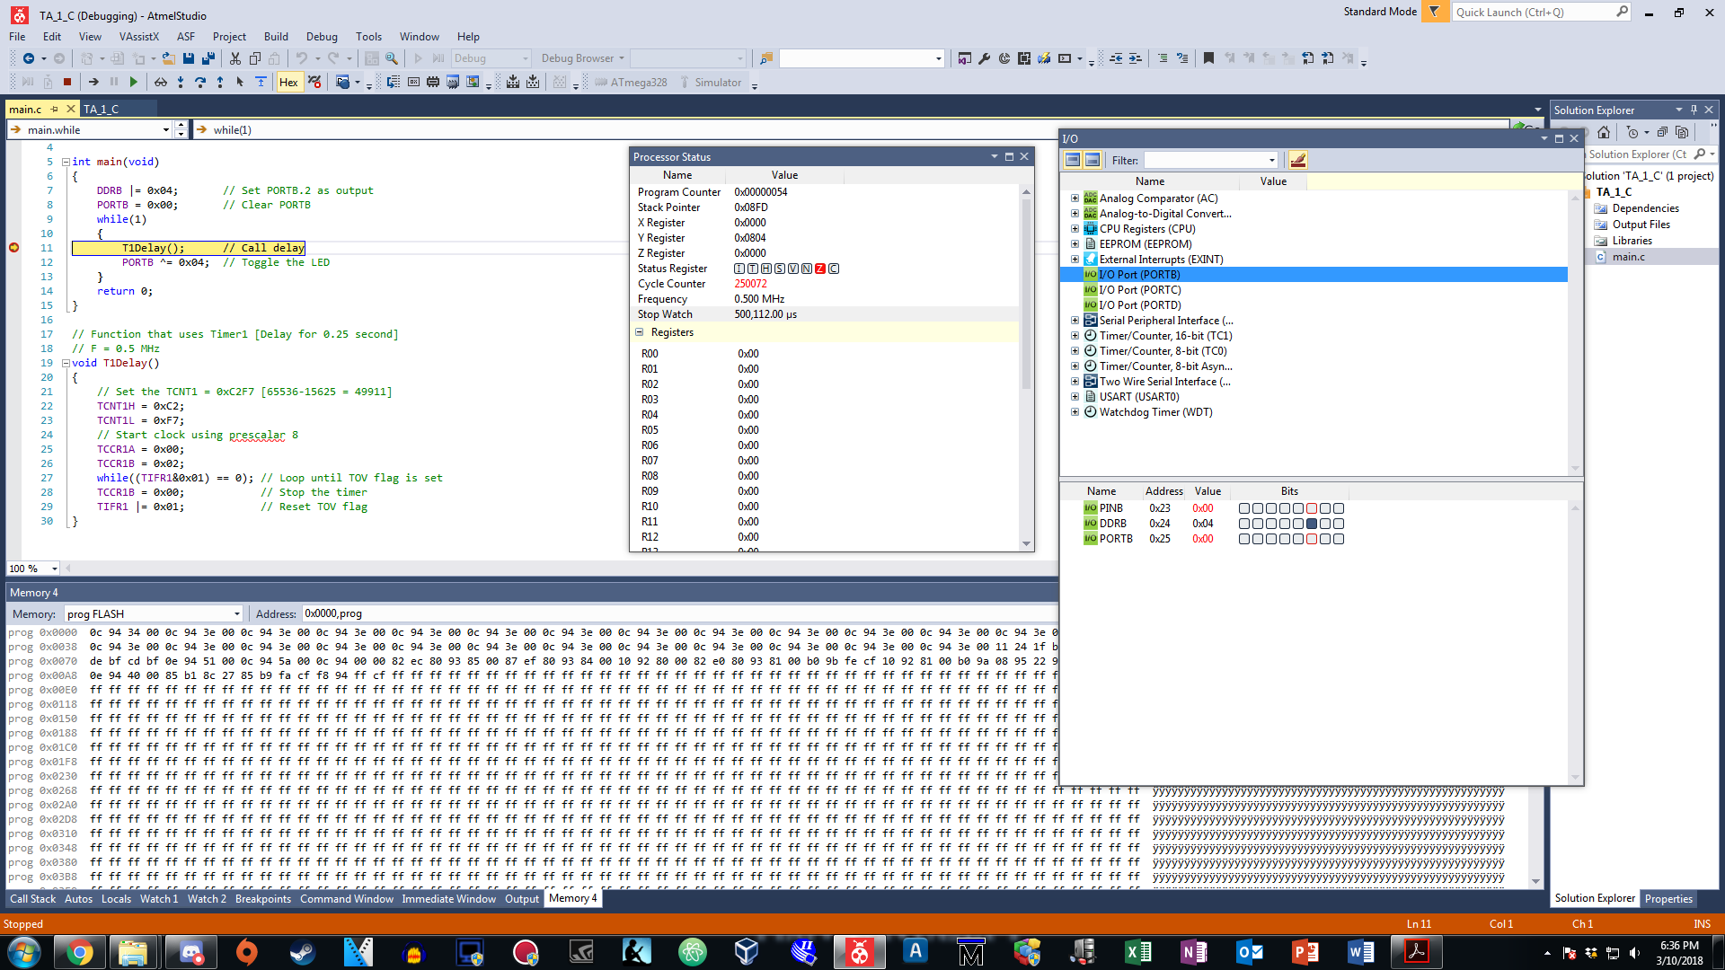

*Figure 8: Another 0.25 second of delay, PB.2 toggles to low again (C)*

1. **Task #2 Assembly Code**

.ORG 0

; Initialize stack

LDI R16, HIGH(RAMEND)

OUT SPH, R16

LDI R16, LOW(RAMEND)

OUT SPL, R16

; Port initialization

CBI DDRD, 2 ; Set PORTD.2 as an input

SBI PORTD, 2 ; Pull up the resistor of PORTD.2

SBI DDRB, 2 ; Set PORTB.2 as an output

POLL:

SBIC PIND, 2 ; Poll until PIND.2 is low

RJMP POLL

SBI PORTB, 2 ; Light up the LED

HOLD:

SBIS PIND, 2 ; Poll until the user lets go of the switch

RJMP HOLD

CALL DELAY ; Delay for 1 second after switch is off

CBI PORTB, 2 ; Turn off the LED

RJMP POLL

; Delay subroutine (F = 0.5 MHz) [Delay for 1 second]

DELAY:

; Set the TCNT1 = 65536-62500 = 3036

LDI R20, HIGH(-62500)

STS TCNT1H, R20

LDI R20, LOW(-62500)

STS TCNT1L, R20

; Set timer control register

LDI R20, 0x00

STS TCCR1A, R20

LDI R20, 0x02

STS TCCR1B, R20 ; Start the timer with a prescalar of 8

LOOP:

IN R20, TIFR1 ; Check for the TOV flag

SBRS R20, TOV0

RJMP LOOP

; Stop timer and clear TOV flag

LDI R20, 0x0

STS TCCR1B, R20

LDI R20, (1<<TOV0)

OUT TIFR1, R20

RET

1. **Task #2 C Code**

#include <avr/io.h>

void T1Delay();

int main(void)

{

DDRD = 0x00; // Set PORTD.2 as input

PORTD |= (1<<2); // Pull up the resistor of PORTD.2

DDRB = 0xFF; // Set PORTB.2 as output

PORTB = 0x00; // Clear PORTB

// Poll until switch is pressed

while(1)

{

if((PIND&0x04) == 0x00)

{

PORTB = (1<<2); // Turn on LED

while((PIND&0x04) == 0x00); // Poll until switch is turned off

T1Delay(); // Call the delay after switch is turned off

}

PORTB = 0x00; // Turn off LED

}

return 0;

}

// Delay subroutine for Timer1 [Delay for 1 second]

// F = 0.5 MHz

void T1Delay()

{

// Set the TCNT1 = 65536-62500 = 3036 [0xBDC]

TCNT1H = 0x0B;

TCNT1L = 0xDC;

// Start Timer1 with prescalar 8

TCCR1A = 0x00;

TCCR1B = 0x02;

while((TIFR1&(1<<TOV1)) == 0x00); // Check TOV flag

TCCR1B = 0x00; // Stop Timer1

TIFR1 |= (1<<TOV1); // Reset TOV flag in TIFR1 register

}

1. **Task #3 Assembly Code**

.ORG 0

; Initialize the stack

LDI R16, HIGH(RAMEND)

OUT SPH, R16

LDI R16, LOW(RAMEND)

OUT SPL, R16

SBI DDRB, 2 ; Set PORTB as output

LDI R16, (1<<2) ; Output signal of PORTB

LDI R17, 0x00

OUT PORTB, R17 ; Clear PORTB

; Toggle PB2

BEGIN:

RCALL DELAY

EOR R17, R16 ; Toggle logic

OUT PORTB, R17 ; Output the toggled signal

RJMP BEGIN

; Delay for 0.25 second

; Delay subroutine using Timer0 (F = 0.5 MHz)

DELAY:

; Set TCNT0 = 256-122 = 134

LDI R20, -122

OUT TCNT0, R20

; Start the timer with a prescalar of 1024

LDI R20, 0x00

OUT TCCR0A, R20

LDI R20, 0x05

OUT TCCR0B, R20

; Delay for 134 cycles by checking the TOV0 flag

LOOP:

IN R20, TIFR0

SBRS R20, TOV0

RJMP LOOP

; Stop timer and reset TOV flag

LDI R20, 0x00

OUT TCCR0B, R20

LDI R20, (1<<TOV0)

OUT TIFR0, R20

RET

1. **Task #3 C Code**

#include <avr/io.h>

void T0Delay();

int main(void)

{

DDRB |= 0x04; // Set PORTB.2 as output

PORTB = 0x00; // Clear PORTB

while(1)

{

T0Delay(); // Call delay

PORTB ^= 0x04; // Toggle the LED

}

return 0;

}

// Delay for 0.25 second

// Delay subroutine using Timer0 (F = 0.5 MHz)

void T0Delay()

{

TCNT0 = 0x86; // Set TCNT0 = 256-122 = 134

TCCR0A = 0x00;

TCCR0B = 0x05; // Start the timer0 with a prescalar of 1024

while((TIFR0&0x01) == 0);

TCCR0B = 0x00; // Stop timer0

TIFR1 |= (1<<TOV0); // Reset TOV flag

}

1. **Task #3 Simulation**

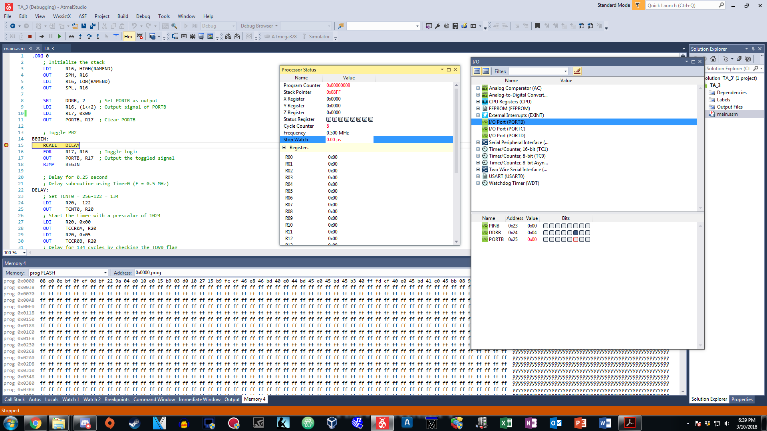

*Figure 1: Before the call of delay, PB.2 is cleared and stopwatch ready (ASM)*

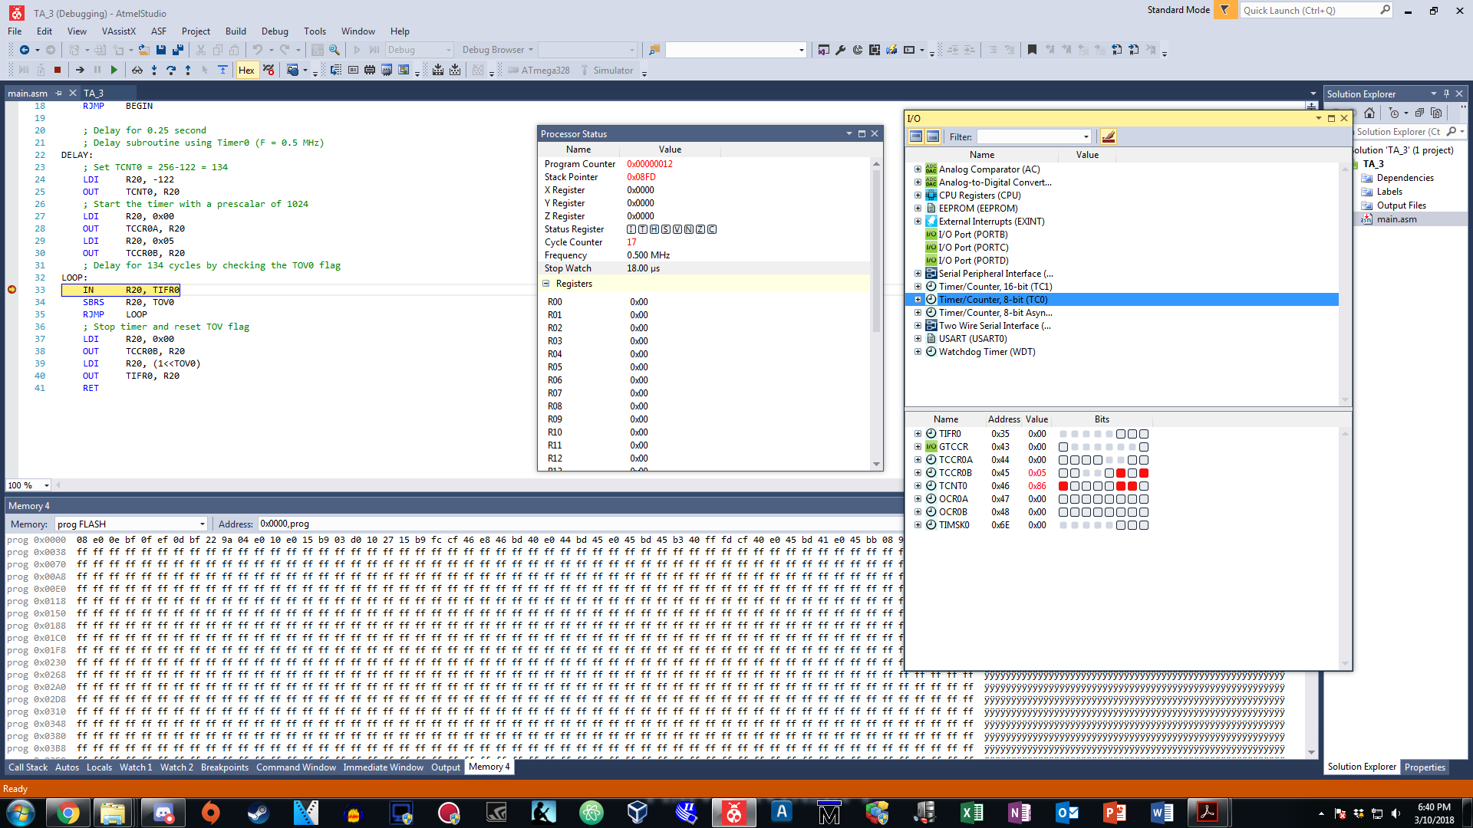

*Figure 2: TIMER0 registers are set to count in the delay subroutine (ASM)*

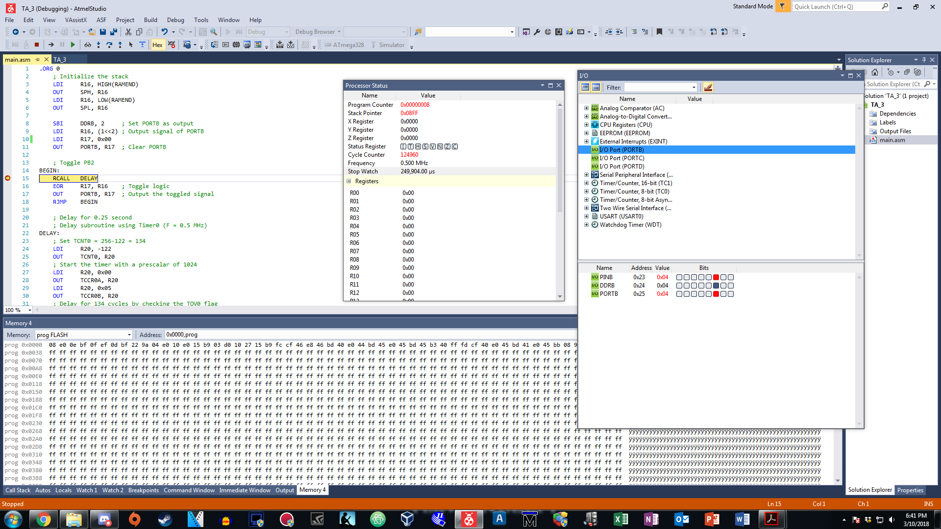

*Figure 3: After 0.25 second delay, PB.2 toggles high (ASM)*



*Figure 4: Another 0.25 second of delay, PB.2 toggles to low again (ASM)*

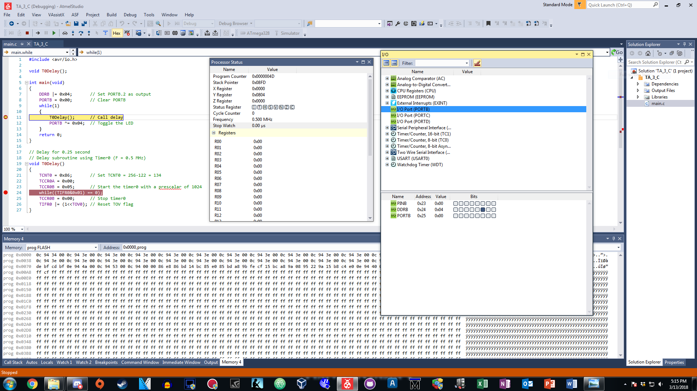

*Figure 5: Before the call of delay, PB.2 is cleared and stopwatch ready (C)*

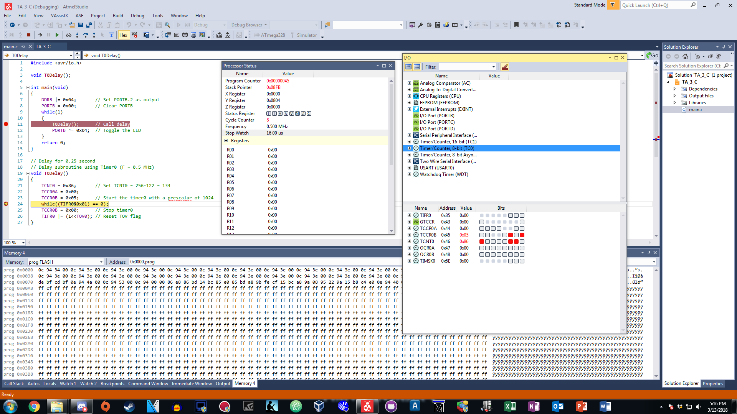

*Figure 6: TIMER0 registers are set to count in the delay subroutine (C)*

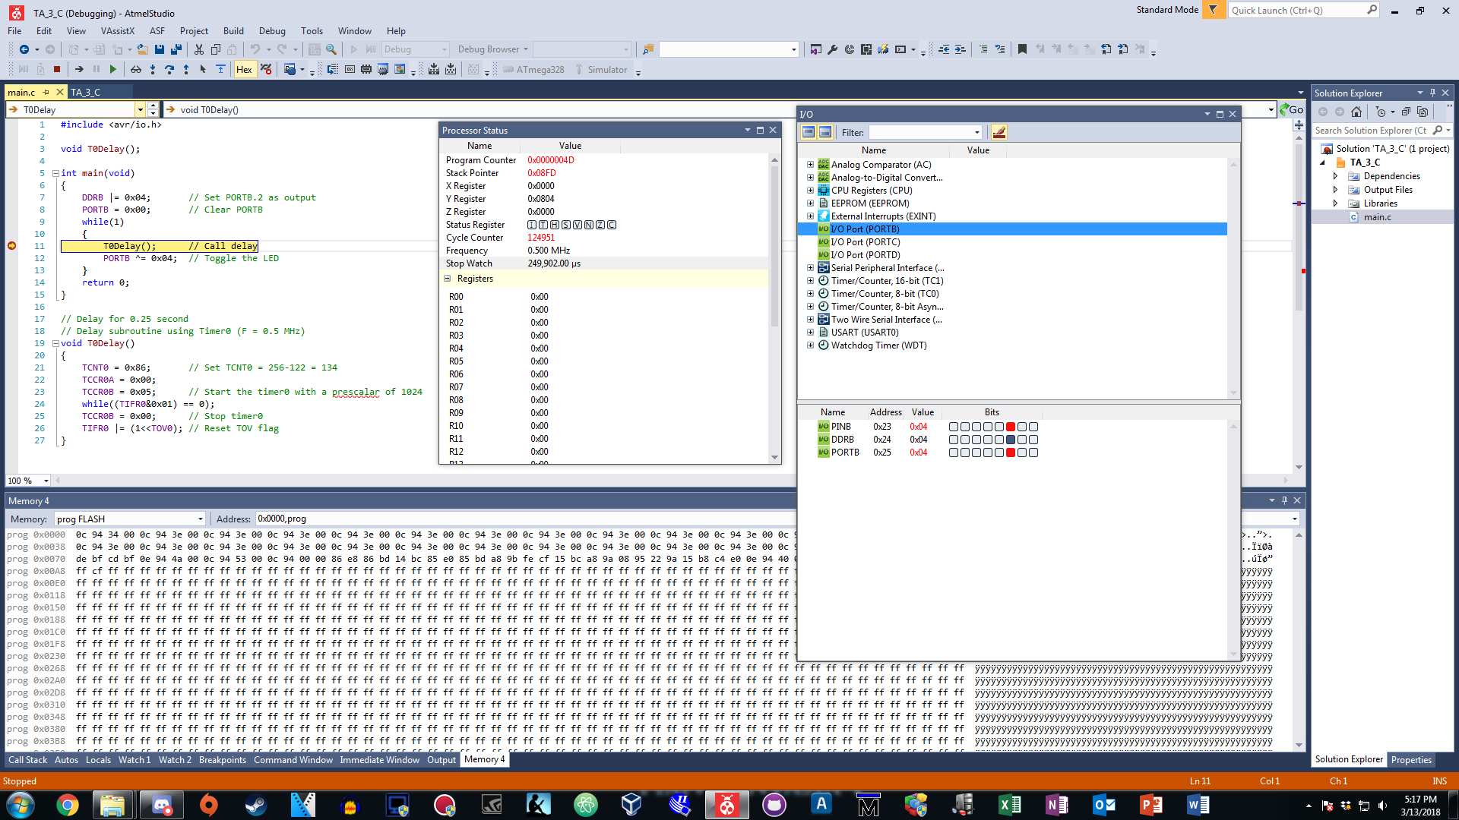

*Figure 7: After 0.25 second delay, PB.2 toggles high (C)*

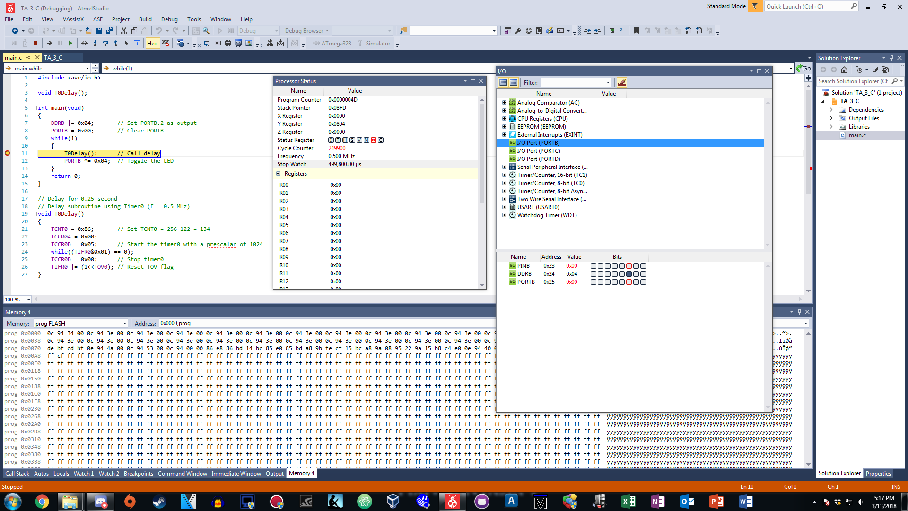

*Figure 8: Another 0.25 second of delay, PB.2 toggles to low again (C)*

1. **Task #4 Assembly Code**

.ORG 0x0000

JMP MAIN

.ORG 0x0020

JMP TIMER0_OVF_ISR

.ORG 0x0100

MAIN:

; Initialize the stack

LDI R16, HIGH(RAMEND)

OUT SPH, R16

LDI R16, LOW(RAMEND)

OUT SPL, R16

SBI DDRB, 2 ; Set PORTB.2 as output

LDI R16, (1<<2) ; Value for toggling the LED

LDI R17, 0x00

OUT PORTB, R17 ; Clear PORTB register

LDI R20, -122 ; 256-122 = 134 cycles (DELAY)

OUT TCNT0, R20 ; Load 134 into TCNT0

LDI R20, (1<<TOIE0)

STS TIMSK0, R20 ; Enable TIMER0 interrupt for OVF

SEI ; Enable interrupts

LDI R20, 0x00

OUT TCCR0A, R20

LDI R20, 0x05

OUT TCCR0B, R20 ; Start TIMER0 with a prescalar of 1024 (F = 0.5 MHz)

LOOP:

RJMP LOOP ; Infinite loop (Wait until TIMER0_OVF interrupts)

.ORG 0x0200

; ISR for toggling PORTB.2

TIMER0_OVF_ISR:

LDI R20, (1<<TOV0) ; Clear TOV flag

OUT TIFR0, R20

EOR R17, R16 ; Toggle PORTB.2

OUT PORTB, R17

LDI R20, -122

OUT TCNT0, R20 ; Reset TCNT0

RETI

1. **Task #4 C Code**

#include <avr/io.h>

#include <avr/interrupt.h>

int main(void)

{

DDRB = (1<<2); // Set PORTB.2 as output

TCNT0 = 0x86; // Set TCNT0 = 134 (DELAY)

TIMSK0 = (1<<TOIE0); // Enable TIMER0 interrupt for OVF

sei(); // Enable global interrupts

TCCR0A = 0x00;

TCCR0B = 0x05; // Start TIMER0 with a prescalar of 1024 (F = 0.5 MHz)

PORTB = 0x00; // Clear PORTB

// Poll until the interrupt occurs

while(1)

{

}

return 0;

}

// Subroutine to handle the TIMER0 OVF interrupt

// Clear TOV, toggle PB.2, and reset TCNT0

ISR(TIMER0_OVF_vect)

{

TIFR0 = (1<<TOV0); // Clear TOV flag

PORTB ^= (1<<2); // Toggle PORTB.2

TCNT0 = 0x86; // Reset TCNT0 count back to 134

}

1. **Task #4 Simulation**

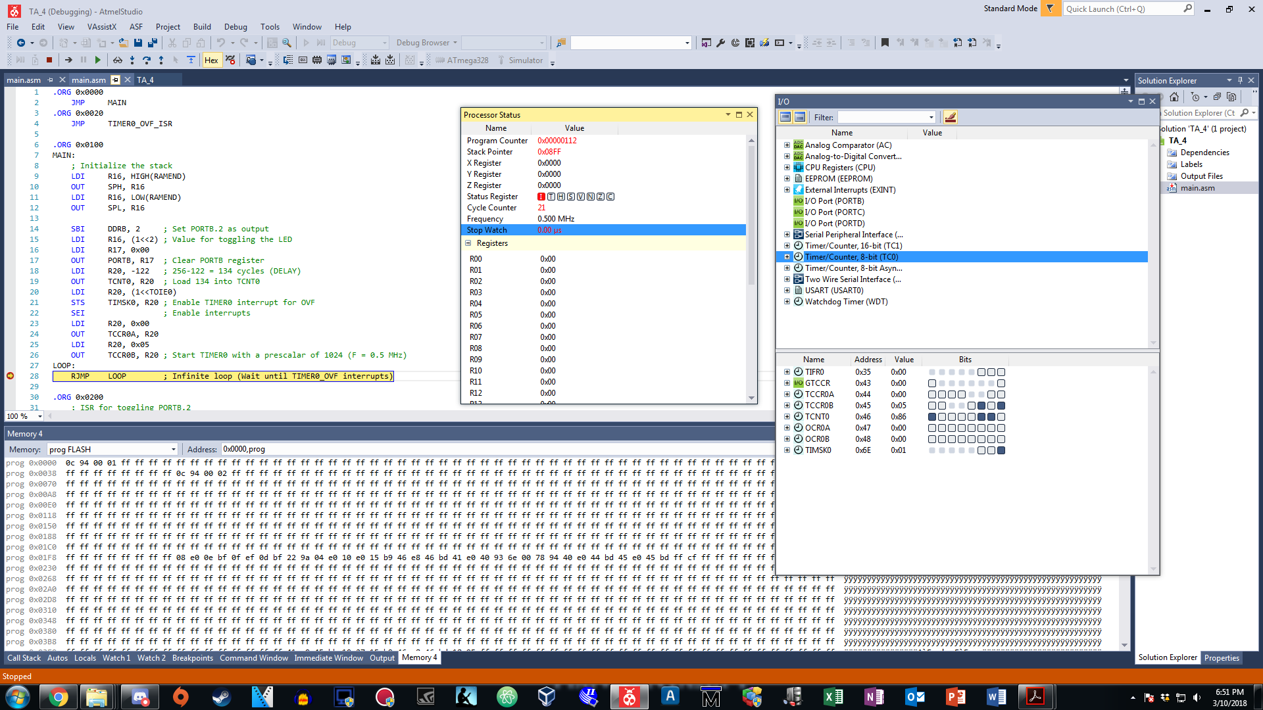

*Figure 1: Before the interrupt, Timer0 interrupt registers are set (ASM)*

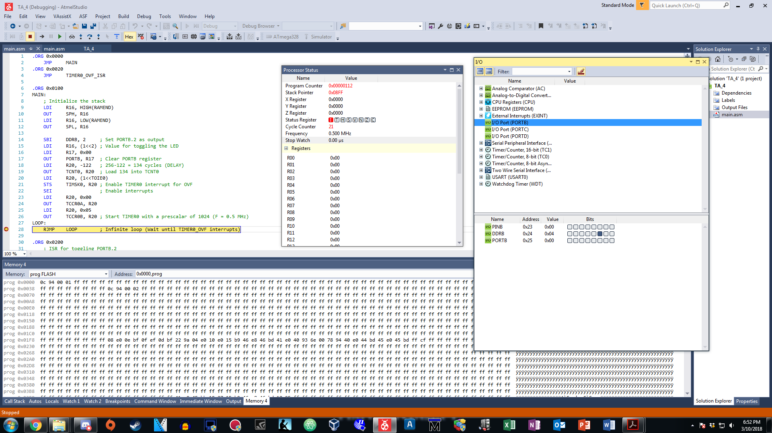

*Figure 2: Before the interrupt, stopwatch is set and PB.2 is cleared (ASM)*

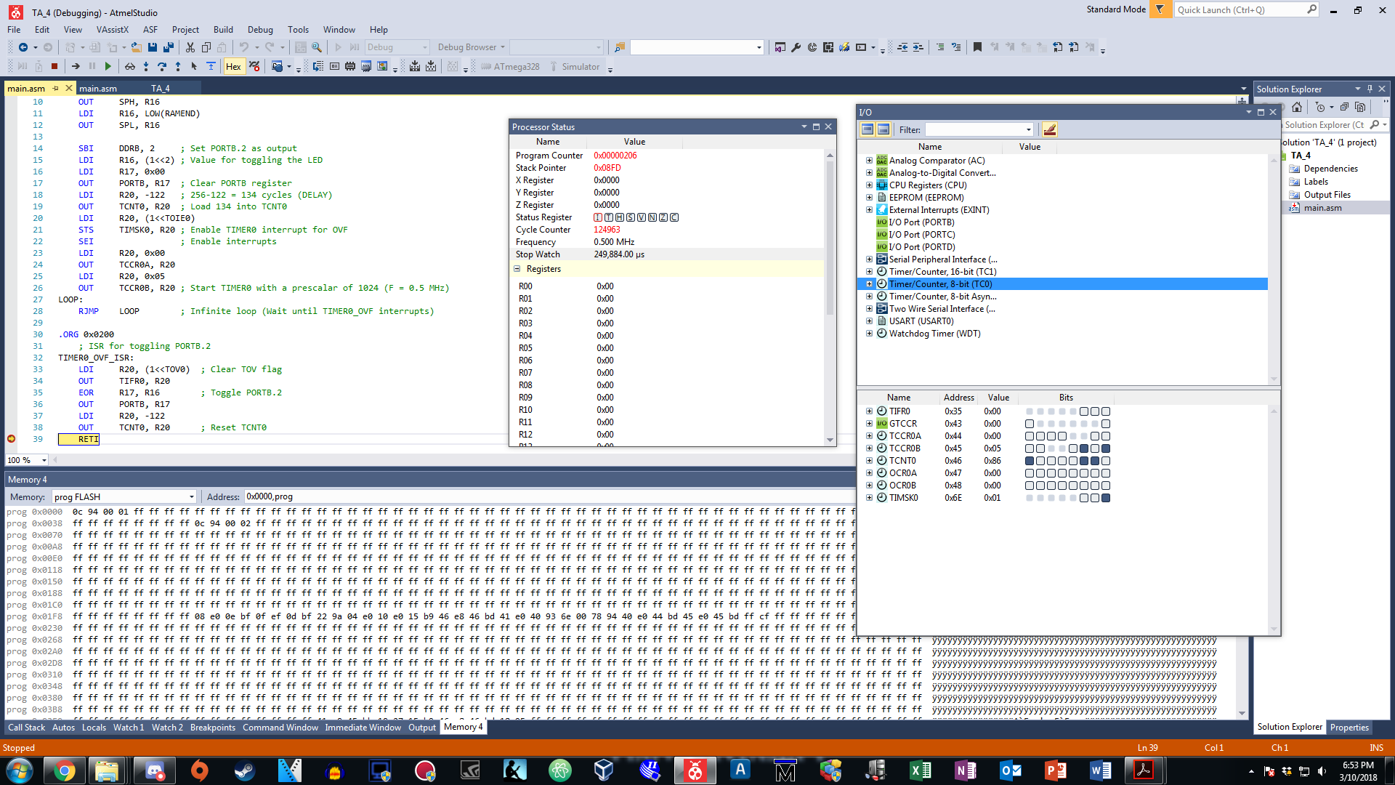

*Figure 3: Interrupt occurred and serviced in the ISR by clearing the flag (ASM)*

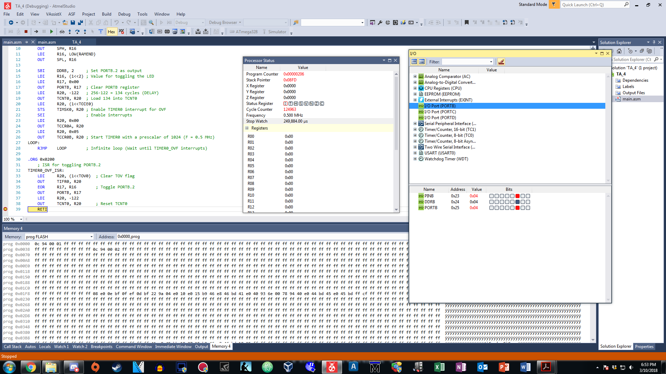

*Figure 4: PB.2 is toggled in the ISR after 0.25 second of delay (ASM)*

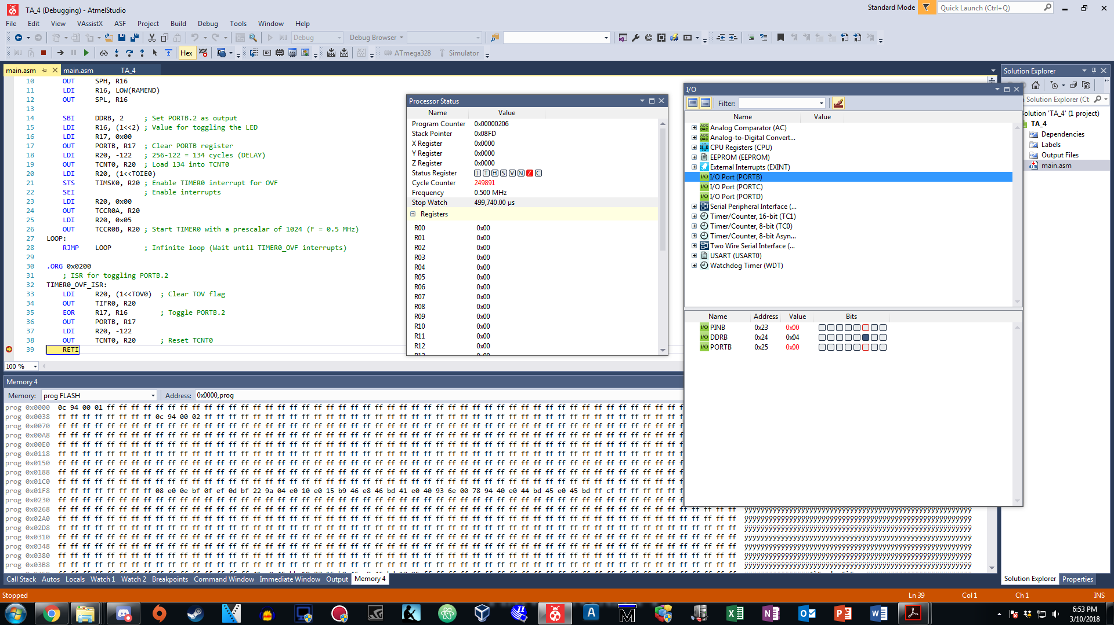

*Figure 5: PB.2 is toggled in the ISR again after 0.25 second of delay (ASM)*

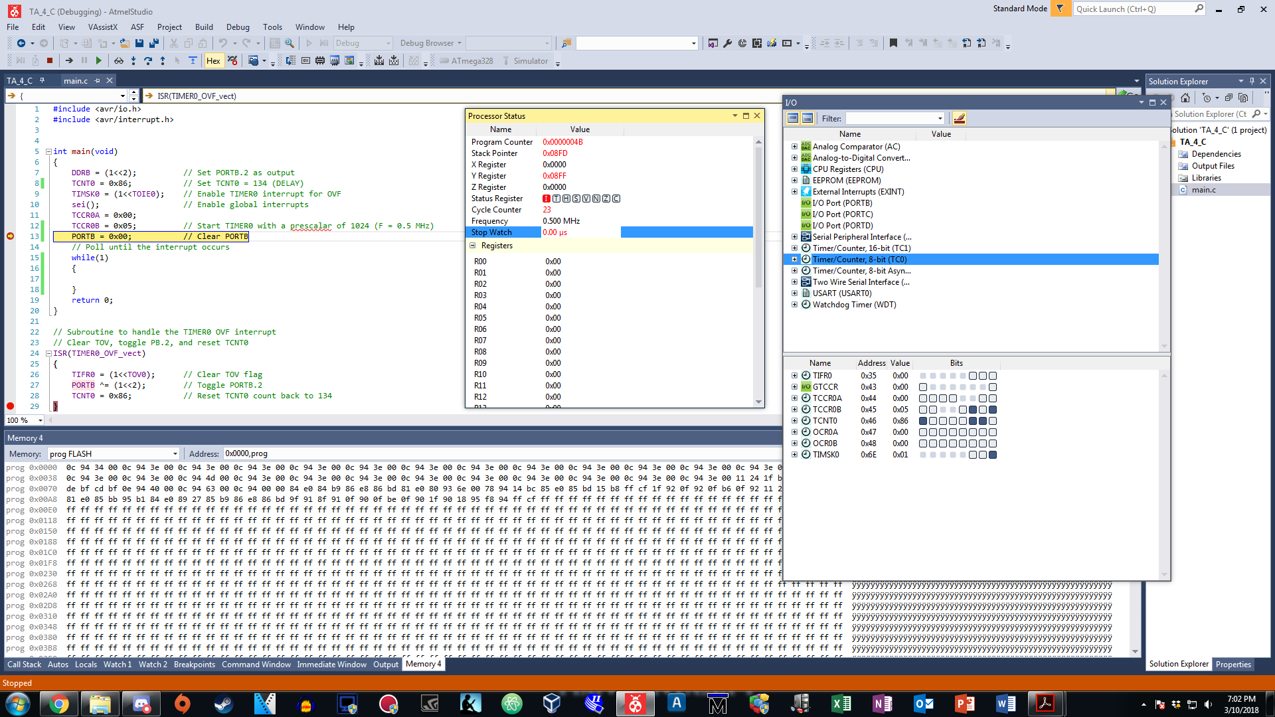

*Figure 6: Before the interrupt, Timer0 interrupt registers are set (C)*

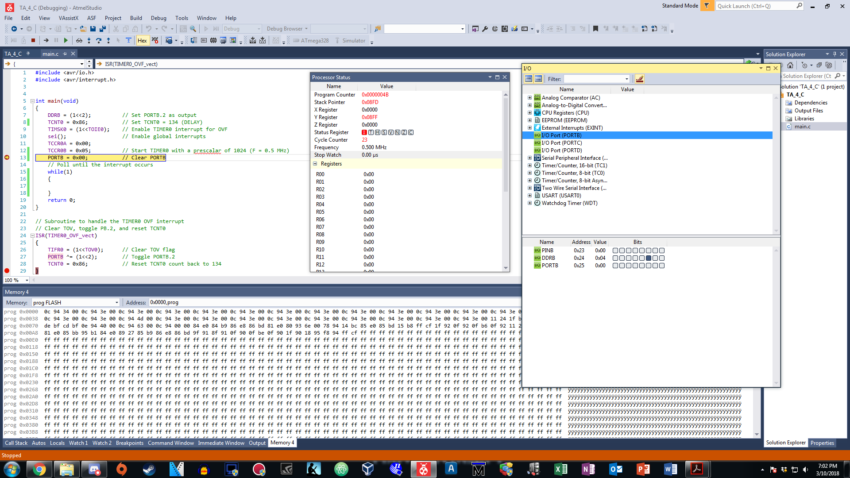

*Figure 7: Before the interrupt, stopwatch is set and PB.2 is cleared (C)*

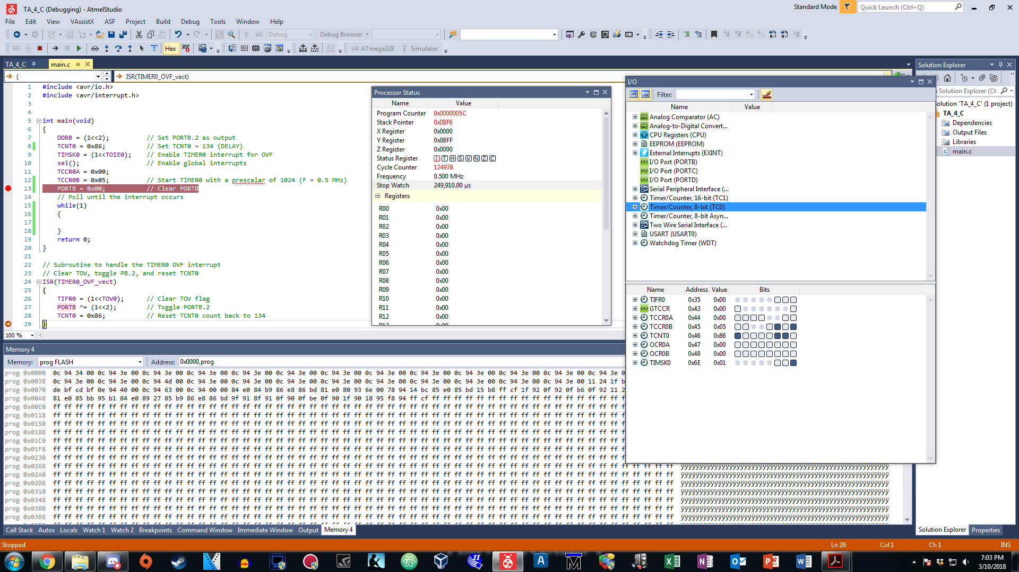

*Figure 8: Interrupt occurred and serviced in the ISR by clearing the flag (C)*

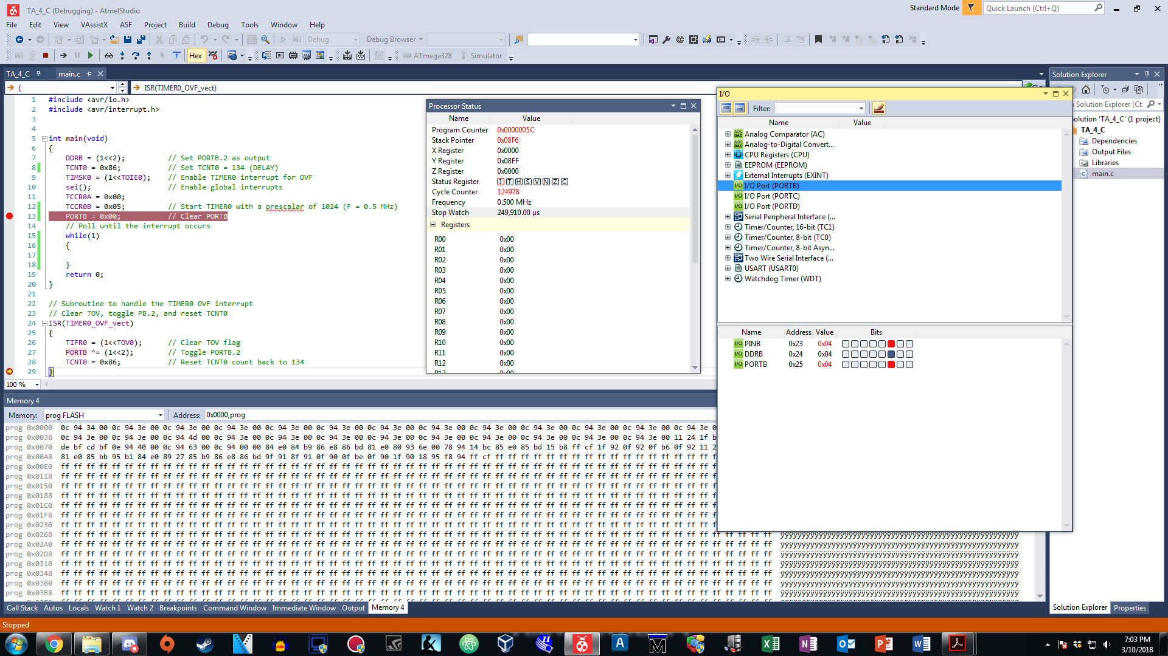

*Figure 9: PB.2 is toggled in the ISR after 0.25 second of delay (C)*

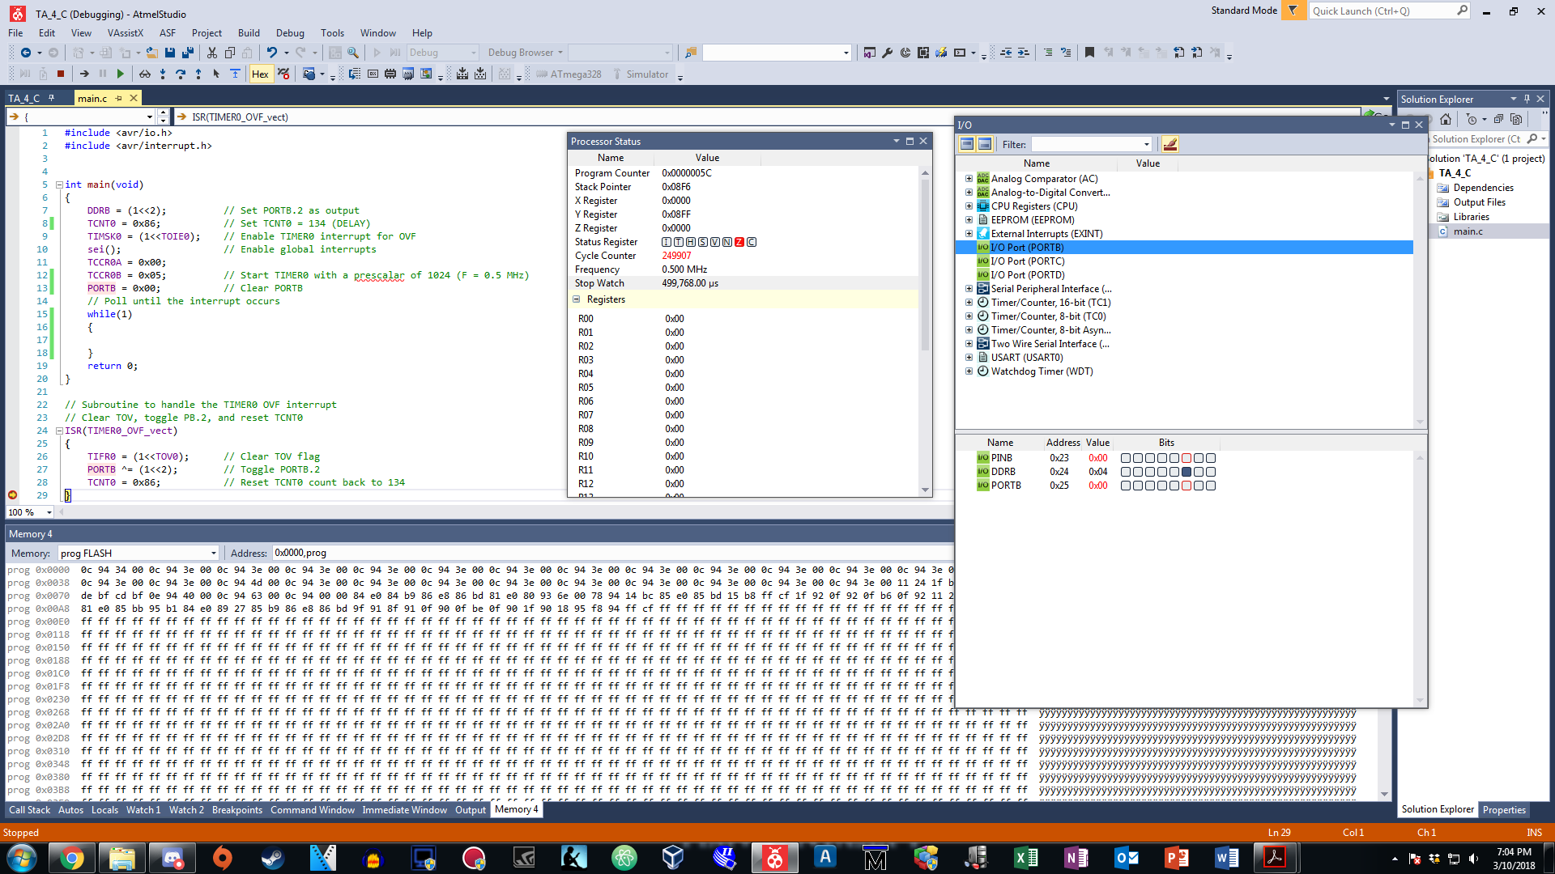

*Figure 5: PB.2 is toggled in the ISR again after 0.25 second of delay (C)*

1. **Task #5 Assembly Code**
2. **Task 5 C Code**
3. **VIDEO LINKS OF EACH DEMO**
4. **GITHUB LINK OF THIS DA**

**Student Academic Misconduct Policy**

<http://studentconduct.unlv.edu/misconduct/policy.html>

“This assignment submission is my own, original work”.

NAME OF THE STUDENT